**INPUT VALIDATION**

* Code used python
* Tool used text editor
* Libraries used

1. Sys (I/O function)
2. Re (evaluate name and numbers)
3. Sqlite(database)

* Database phonenumber.db will be created
* Phonenumber.db contains names and phone numbers
* Operations performed
  1. ADD-- This method checks the input format and adds the name and number to database
  2. DEL—This method deletes the names in the database, if there are same names it asks for phone number and then deletes the name corresponding to the number given
  3. LIST—Show the list of records in the database
* Name validation code : "^[A-Z]\\'?([a-zA-Z]*?\\'?[a-zA-Z]*?\\,?[ ]?\\'?\\-?\\.?){1,3}$"
* Number validation code: "(^\\d{5}$)|(^\\d{5}\\.\\d{5}$)|(^\\+[1-9]{1,2}[ ]?\\(|^[1][ ]?\\(|^[0][1][1][ ][1]?[ ]?\\(?|^\\(?)([1-9]\\d{1,2})?\\)?[- ]?(\\d{3})[-| ](\\d{4})$"
* The print menu statement in the code shows the options we can perform
* NameValidation method checks the format of the name given as input
* NumberValidation method checks for the format of the number that is given as input
* Assumptions of the program
  1. We give name and then phone number as inputs
  2. We can have same name but should have different phone numbers
  3. The can be run at command line
  4. As sqlite is free we use it as database to store the data
* Pros
  1. The code accepts only valid inputs which are validated through regex
  2. As we used parametrised queries sql injection attacks can be prevented
* Cons
  1. ADD method can only use name as first input and then accepts number as second input
  2. Only the command format mentioned in the code can be used
* Bonus
  1. We use sqlite as database and also use prepared statements which support parametrized queries

**Screenshots of operations performed**

After the code execution we can see the menu which shows us the operations that can performed

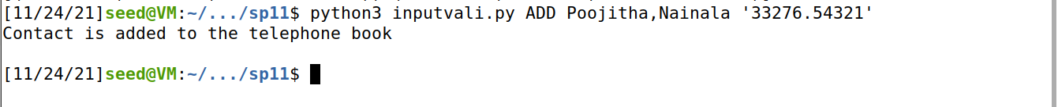

ADD operation, we can see that the contact is added to telephone book



After adding the contacts, we can see the ist of contacts present using LIST operation

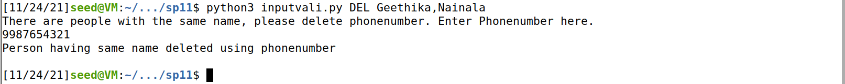

When we try to delete a contact with same name it will ask us to enter phone number



We can see that the contract having same name is deleted according to the phone number we gave



If there is only one name, we can directly delete the contact using DEL operation



We can see that contact is deleted form the list